**PRACTICAL 3**

**Aim : Study and implementation of Infrastructure as a Service**

Download the Own Cloud X Server from the link below.(It only works with 64bit system) <https://owncloud.com/download/>

Scroll down and Select **Virtual Box** button in the Appliance section

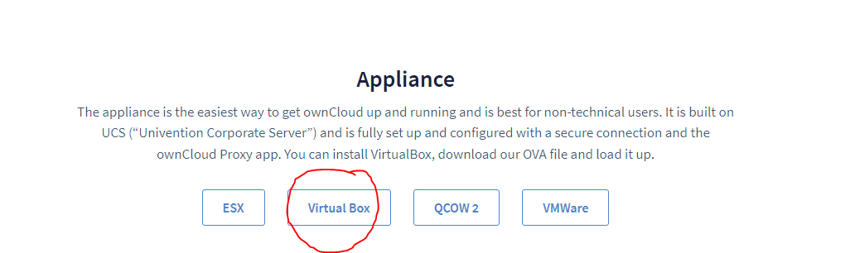

**Extract it, you will get virtual machine file name "UCS".**

**Open VMware. Click on "Open a Virtual Machine"**

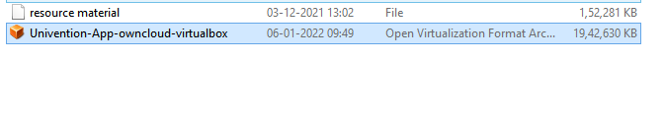

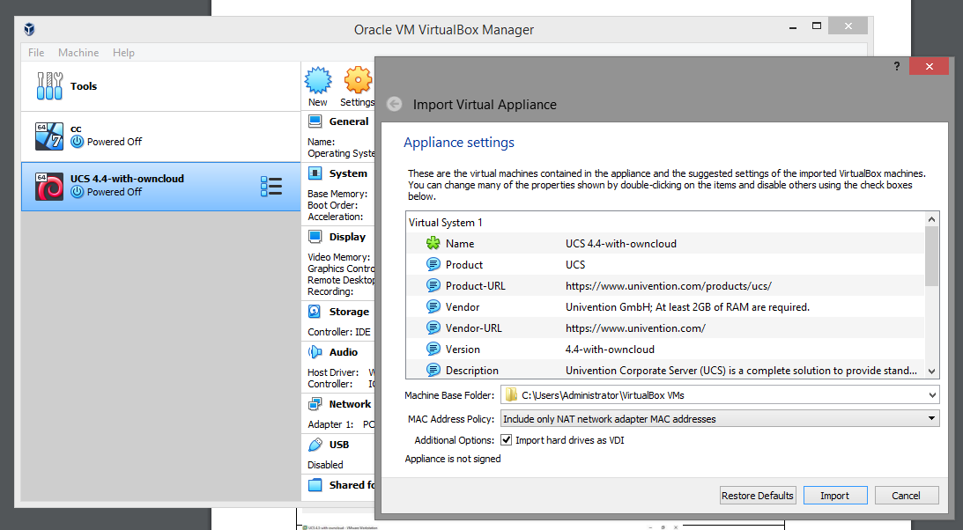

**Select "UCS" and click open.**

**Click on "Power on this virtual machine".**

**Following window willappear using old version**



Using new version

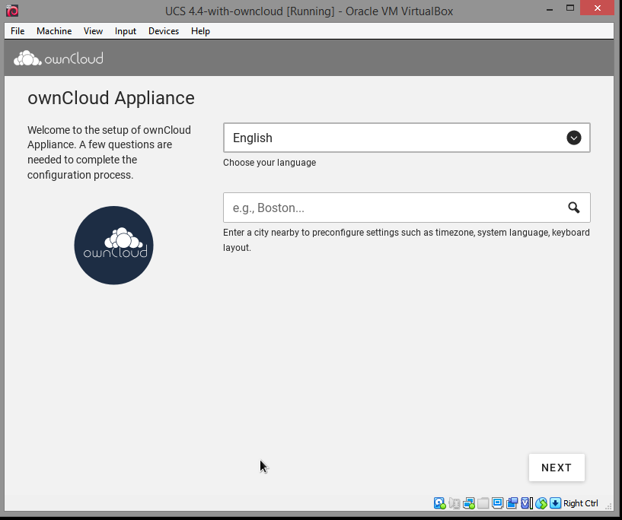

**On next window it will ask you for your “city”, don’t enter any city name in it and just click “NEXT” (Most important step please don’t enter any city name in it otherwise it will not read keyboard entries). Just click “NEXT” on “Localization settings” window.**



**It will fetch IP Address, Net Mask and Gateway from DHCP, don’t change anything and just click “NEXT”.**

**In Domainsetup click “NEXT”.**

**Now Account information window will appear,enter details in it. Remember that password we are setting is for “root” and “Administrator”, click on“NEXT”**





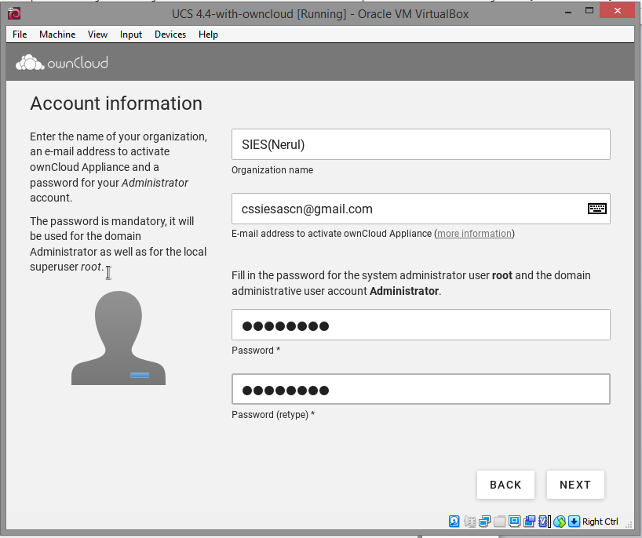

**On next window it will show you Fully Qualified domain name and LDAP base, click on“NEXT”.**

**It will show the configuration settings for owncloud scroll down a little and click on “CONFIGURESYSTEM”**







**It will take time to setup.**

**Yes setup is done now click on “FINISH”.**

**Now on next window press any button.**







**Now you can see the IP address on top right hand side, open the browser and enter system’s IP address in URL bar and press enter.**

**It will ask you for Email ID to send license, enter your Email ID and click “REQUEST ACTIVATION”.**







**Checkyourmailboxyouwillreceivethelicensefrom Own Cloud,download it.. Get back to Own Cloud and click on “UPLOAD LICENSE FILE”.**

**Now select the license file and click “Open”.**







**On next page click on “FINISH”.**

**Yes we have installed OwnCloud, now just try logging inwith “Administrator” as user for that click on button.**







**Enter “Administrator” as user name and the password which you set during setting up process and click on “LOGIN”.**

**Yes we have logged in successfully, now click on button.**







**Yes we successfully completed OwnCloud installation.**

